**Container health**



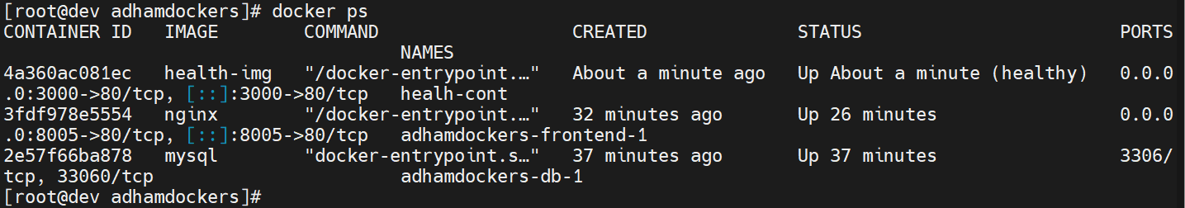



**Delete the Nginx Default Web Directory**

